FORM DESIGN

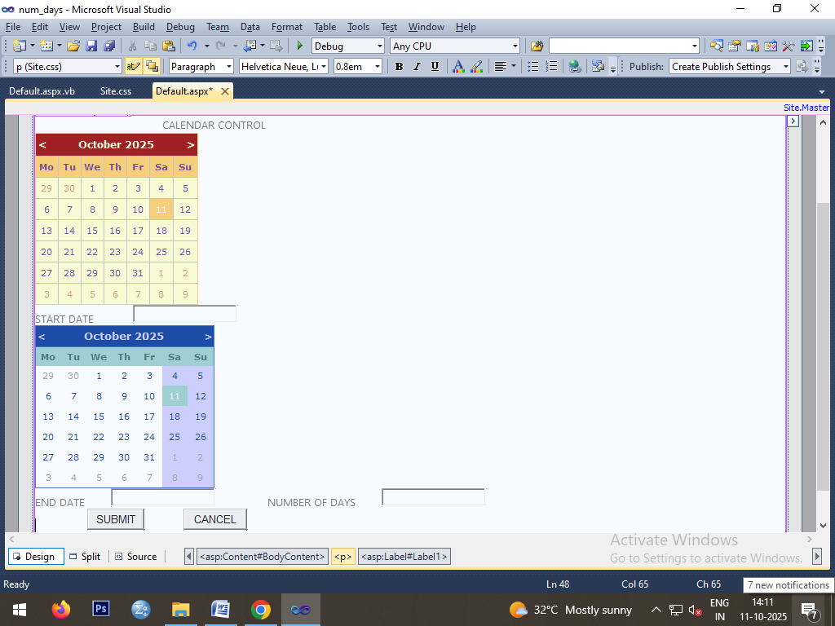

CODING

Public Class _Default

Inherits System.Web.UI.Page

Protected Sub Button2_Click(ByVal sender As Object, ByVal e As EventArgs) Handles Button2.Click

TextBox1.Text = " "

TextBox2.Text = " "

TextBox3.Text = " "

End Sub

Protected Sub Button1_Click(ByVal sender As Object, ByVal e As EventArgs) Handles Button1.Click

Dim DAYS As Integer

Dim sdate, edate As DateTime

sdate = DateTime.Parse(TextBox1.Text)

edate = DateTime.Parse(TextBox2.Text)

DAYS = (edate - sdate).Days

TextBox3.Text = DAYS

End Sub

Protected Sub Calendar1_SelectionChanged(ByVal sender As Object, ByVal e As EventArgs) Handles Calendar1.SelectionChanged

TextBox1.Text = Calendar1.SelectedDate

End Sub

Protected Sub Calendar2_SelectionChanged(ByVal sender As Object, ByVal e As EventArgs) Handles Calendar2.SelectionChanged

TextBox2.Text = Calendar2.SelectedDate

End Sub

End Class

OUTPUT

